What is a Wiki?
A wiki is a web based publication or content system that is collaboratively edited and managed by its own audience directly. A typical wiki contains multiple pages for the subjects or scope of the project.
Probably the best known example of a Wiki is Wikipedia. Wikis are enabled by wiki software such as Wikimedia (in the case of Wikipedia) or, closer to home, Confluence. A wiki is a form of a content management system. It differs from other content management systems such as blog software, in that the content is created without any defined owner or leader, and wikis have little inherent structure, allowing structure to emerge according to the needs of the users.
Wikis were invented by Ward Cunningham who said it this way:
“The idea of a “Wiki” may seem odd at first, but dive in, explore its links and it will soon seem familiar. “Wiki” is a composition system; it’s a discussion medium; it’s a repository; it’s a mail system; it’s a tool for collaboration. We don’t know quite what it is, but we do know it’s a fun way to communicate asynchronously across the network.” – Ward Cunningham
When used by a corporation a Wiki can be (and has been) used to capture Team information, procedures, practices, meeting notes, decisions, glossaries, product documentation (Atlassian document Confluence use in Confluence and publish from that source), frequently asked questions (FAQs), requirements, reports, diagrams, etc.
There are a number of differences when a corporation uses a Wiki as a knowledge repository, in comparison to more traditional knowledge repositories:
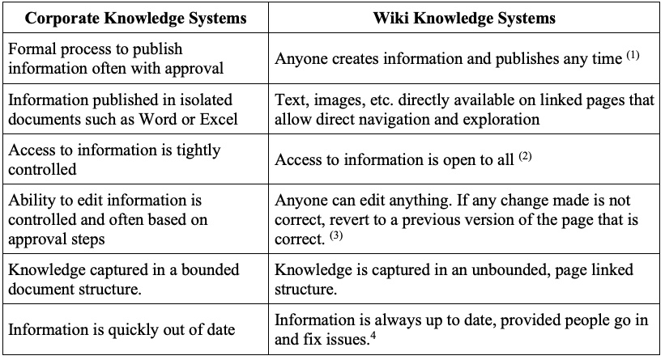
1. The basic idea of a Wiki is that every page has a “Create” button and anyone can access this button 2. Can control access, but in most cases you don’t. 3. Every “publish” creates a new version of the page automatically 4. Wikipedia is as at least as accurate as the Encyclopedia Brittanica, with far wider subject reach, and if a problem is detected on Wikipedia, you don’t have to wait for the next version of the Encyclopedia to be published to ensure up to date information.

